December 11th, 2011
Hi

Last night, I stayed up late to watch part of a total eclipse of the moon. It was a good night for viewing, with a perfectly clear sky. And it was clearly visible right outside the hotel in spite of all the ambient lighting. The whole process lasted about six hours but the time when the moon was totally eclipsed lasted about 51 minutes. I watched it on and off for about 1 ½ hours, both downstairs and on the Observatory website. The moon did not completely disappear as I expected, but appeared coppery-red in colour during totality. This is because sunlight, scattered by the Earth's atmosphere, is projected onto the moon making it partially visible.
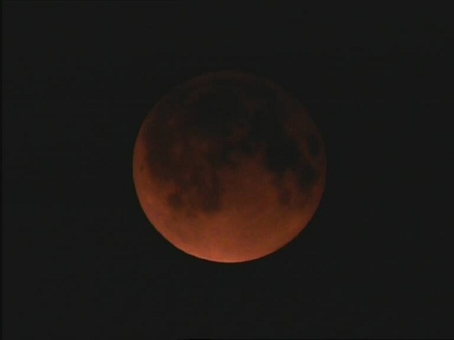
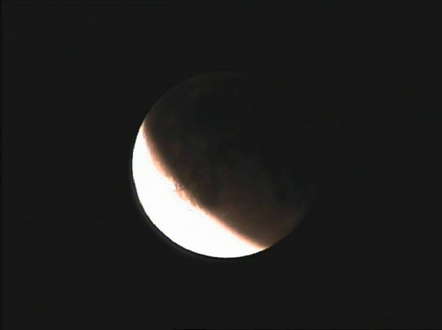

about 10.30 pm about 11.30 pm
(middle of total eclipse) (coming out of the total eclipse)
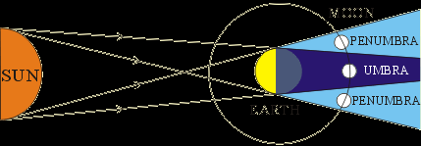

(total eclipse/blocking of moon)
(partial eclipse - some light from sun on the moon)
You can see the eclipse, lasting just a few seconds, at this Observatory website:
http://www.weather.gov.hk/gts/hksm/astrophoto.htm
I mentioned last week about the rigging of votes in the recent election. Now both the Police and the ICAC are involved. Last Monday, 22 people (20 of whom actually voted) were arrested by the ICAC for vote rigging in a constituency where the winner won by just 2 votes. All 22 had registered the same residential address though no-one actually lived there and the actual residents said they did not know any of them. Since then, more have been arrested. Today there is another election. Some people are voting to elect the 1200 who will choose the next chief executive. Only about 800 seats are up for selection; the others have been elected unopposed. I am not sure who are voting, but it does not include me. I have just heard on the radio news that it involves about 250 000 people from different sections of society, such as education, medicine, business, medicine, etc. - something like the election of the 'functional' constituency members of the legislative council.
Another thing I have mentioned in the past is the problem of mainland women coming to HK to give birth and how the government has set a cap of about 34 000 annually in order not to overload local hospitals. Well, hundreds of pregnant mainland woman have still been coming and turning up at the hospital Accident & Emergency departments at the last minute demanding to give birth. So now they are being turned away at the border unless they have documents to prove that are allowed to give birth here.
The run yesterday was not bad. At 2 h 12 min, it was 2 minutes slower than last year but the same as the last time I did it three years ago. It was a fine day but quite cool at about 11⁰C. I wore a pullover for the whole run. (My decision on whether to wear a pullover depends on the temperature after I get up; if it is 14⁰C or lower, I put on a pullover, though as the run progresses and I get hot, I sometimes need to take it off.)
This weekend. the third round of the IRB 7s was held in South Africa. NZ won the tournament, beating SA 31-26 with a try in the last play of the game. The first tournament was on the Gold Coast and the second last weekend in Dubai. This was NZ's first win in the current series. (I note from last year's letter that NZ also won in SA, beating England, in the last few seconds.)
Two HK tourists killed and about 34 injured in a bus crash in China. This, unfortunately, is not an uncommon occurrence.
Two anniversaries this past week. First there was the 70th anniversary of the attack on Pearl Harbor. Saw a little of the ceremonies that took place in Hawaii. Then, the next day, December 8th, was the 70th anniversary of the Japanese invasion of HK. This lasted until Christmas day when HK surrendered. In Australia, the ABC (non-commercial) is to retain its TV licence rather than it being given to a Murdoch commercial company. It was believed that a commercial company would not do as good a job of representing Australia.
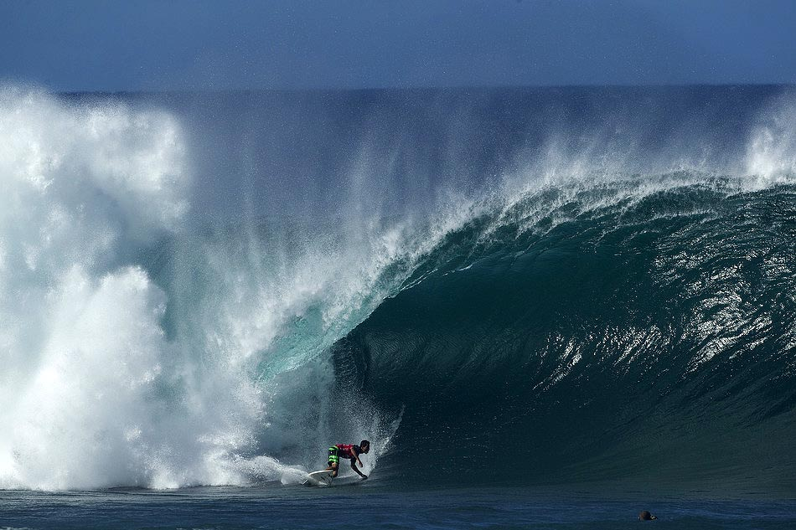
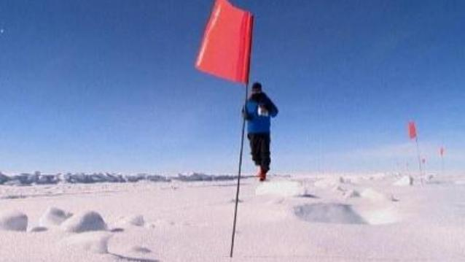
There was also an ABC TV report of a marathon held in the Antarctic. As well as the cold, the other big problem is dehydration. I guess the air is completely dry as any moisture would immediately freeze and fall to the ground. Hence, evaporation from the skin would be very rapid leading to dehydration. Also saw on TV something of the Pipeline Masters in Hawaii. I like watching surfers on these gigantic waves - very impressive. So do a lot of others, I guess, judging by the massive crowds who were there watching. Were you there, Gavin?

In the latest Time magazine, there was a brief article about the sugar content in children's breakfast cereals. The 'top 10' most sugary ones were listed, all with 41% or more of their weight being sugar. The worst was Kellogg's Honey Snacks with 56% of the weight being sugar!! Is it any wonder kids are becoming obese. There was also a comment that the healthier cereals, with few or no added sugars, are usually placed high on shelves, about eye level for most youngsters. I don't think we fed you on this stuff; often it was just straight oat/wheat porridge.
On Friday, I went to a property agency to enquire about renting a flat in the nearby buildings - the ones I can see from my window. Sometime next week, I will go over and have a look at a few of them. The total cost of living there will be only about half that of staying here. A move from 1118 may be a good idea anyway, as I have learnt that the open area below here, where the LRT/tram stops are, construction is to begin on another large block of flats. I have thought of going back to NZ, but I am not too keen on the idea, possibly as I have been so long out of the country. And then, to where? Christchurch is still appealing, in spite of the earthquakes (most places in NZ are subject to earthquakes!). But small places are not, as they have few of the amenities of the larger places.
That’s about it for now.
Cheers

